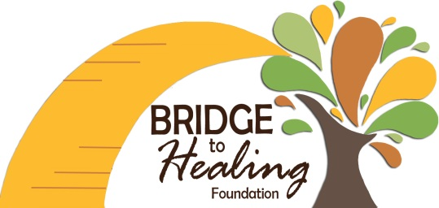

Bridge to Healing
18037 SE Heritage Dr.
Tequesta, FL 33469

Dear Donor,
On behalf of the Board of Directors of Bridge to Healing Foundation, Inc., we want to thank you for your recent donation of $________.

Bridge to Healing Foundation, Inc., a 501(c)(3) non-profit Foundation, was formed to raise funds for special needs children across the country. As those of us involved with special needs children know, therapies are expensive and often not covered by insurance. Some children are even denied coverage based on their diagnosis.

The goal of Bridge to Healing is to raise funds for those children so that they may receive the necessary therapies they need in order to reach their fullest potential in life. Your donation will make a difference to a special child.

We thank you again for your support.

Best Regards,
Bridge to Healing Foundation

“We all walk in the same shoes, just different sizes and styles.”
2013

